Communication

- Please look over the communication competency gradual growth profiles and read the “I” statements.
- Consider what you have done over the past semester, what artifact highlights where are you at within these profiles?
- Highlight where you are at.
- Place a labeled piece of learning evidence within this folder and complete a reflection about your evidence piece, within the reflection box below, stating what you “can do”.

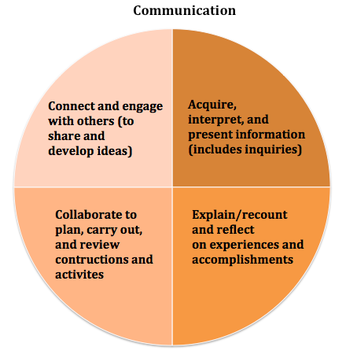

Gradual Growth Over a Lifetime
“I…”
- When comfortable, I can respond to peers and adults.  - I can be part of a group when support. | In familiar situations, with direct support, I communicate with peers and adults.  I understand and share basic information about topics that are important to me. I talk and listen to people I know. I plan and complete activities with peers and adults. I can answer simple direct questions about my activities and experiences. | In familiar situations, with some support or guidance:  - I communicate with peers and adults.  - I understand and share basic information about topics that are important to me, and participate in conversations for a variety of purposes (e.g., to connect, help, be friendly, learn/share).  - I listen and respond to others.  - I can work with others to achieve a short-term, concrete goal.  - I do my share.  - I can recount simple experiences and activities, and tell something I learned. | - I communicate with peers and adults with growing confidence, using forms and strategies I have practiced.  - I gather basic information I need for school tasks and for my own interests, and present it in ways I have learned.  - I am becoming an active listener.  - I ask questions and make connections. - When I talk and work with peers, I express my ideas and encourage others to express theirs.  - I share roles and responsibilities. I recount and comment on events and experiences. | - I communicate clearly, in an organized way, using a variety of forms appropriately.  - I acquire the information I need for school tasks and for my own interests, and present it clearly.  - In discussions and collaborative activities, I am an engaged listener, I ask clarifying and extending questions.  - I share my ideas and try to connect them with others’ ideas.  - I contribute to planning and adjusting a plan, and help to solve conflicts or challenges.  - I am able to represent my learning, and connect it to my experiences and efforts.  - I give and receive constructive feedback. | - I communicate confidently in organized forms that show attention to my audience and purpose.  - I acquire information about complex and specialized topics from various sources, and synthesize and present it with thoughtful analysis. - I contribute positively to discussions and collaborations, and help to organize and monitor the work.  - I ask thought-provoking questions, integrate new information, support others, and help to manage conflicts.  - I offer detailed descriptions of my own efforts and experiences.  - I give, receive, and act on constructive feedback. | - I communicate effectively in well-constructed forms that are effective in terms of my audience purpose.  - I acquire, critically analyze, and integrate well-chosen information from a range of sources.  - I show understanding and control of the forms and technologies I use.  - In discussion and collaboration, I acknowledge different perspectives, and look for commonalities.  - I offer both leadership and support.  - I am flexible and have a variety of strategies and experiences to draw on.  - I am able to represent my learning and my goals, and connect these to my previous experiences.  - I accept constructive feedback and use it to move forward. | - I am intentional and strategic.  - I am able to engage and accomplish my purpose with an increasing range of audiences, including those I do not know.  - I access and make strategic choices from complex and specialized information sources.  - I show expertise in the forms and technologies I use.  - I can take leadership in a discussion or collaboration, and focus on deepening or transforming our thinking.  - I seek consensus, and focus on collective results.  - I can articulate a keen awareness of my strengths, my aspirations and myself.  - I offer detailed analysis, using specific terminology, of my progress, work and goals.
Self Reflection and Artifacts:

