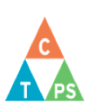

Core Competency Self-Assessment

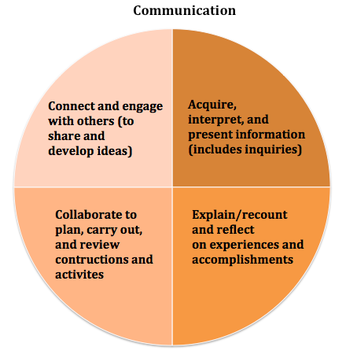

Core Competency | “I...” | My demonstration or artifact and reflection.
Communication

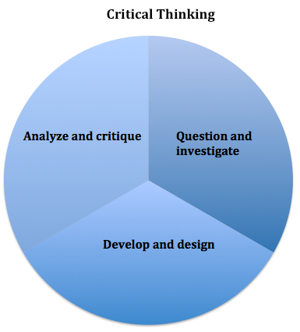

Core Competency | “I...” | My demonstration or artifact and reflection.
Critical Thinking

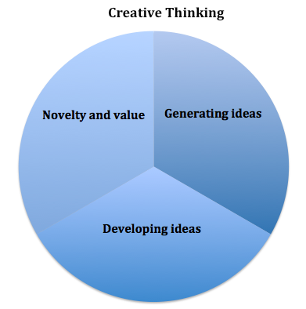

Core Competency | “I...” | My demonstration or artifact and reflection.
Creative Thinking

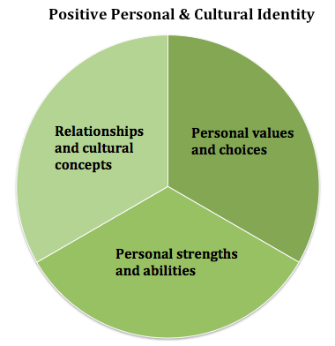

Core Competency | “I...” | My demonstration or artifact and reflection.
Positive Personal and Cultural Identity

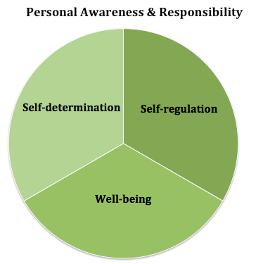

Core Competency | “I...” | My demonstration or artifact and reflection.
Personal Awareness and Responsibility

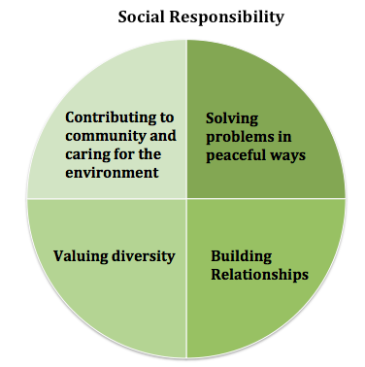

Core Competency | “I...” | My demonstration or artifact and reflection.
Social Responsibility

