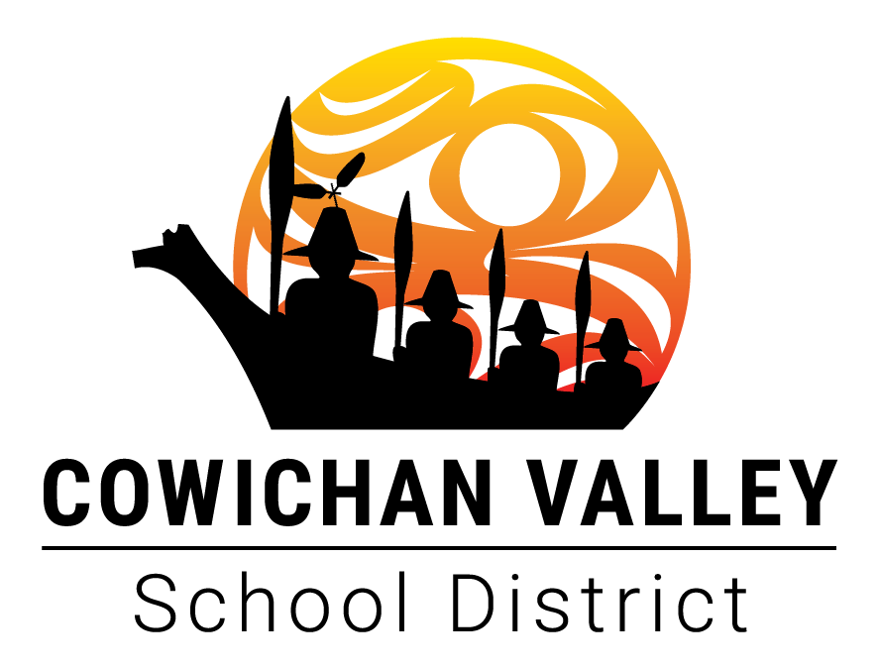 |  | Board/Authority Authorized Course:
 | School District/Independent School Authority Name:  Cowichan Valley School District |  | School District/Independent School Authority Number (e.g. SD43, Authority #432):  SD79 Cowichan Valley
 | Developed by: |  | Date Developed:
 | School Name: |  | Principal’s Name:
 | Superintendent Approval Date (for School Districts only): |  | Superintendent Signature (for School Districts only):
 | Board/Authority Approval Date: |  | Board/Authority Chair Signature:
 | Course Name: |  | Grade Level of Course:
 | Number of Course Credits: |  | Number of Hours of Instruction:
 | Course Category: (Filled in by the developing school) |  | Course Code: (Filled in by the district)

Board/Authority Prerequisite(s):

Special Training, Facilities or Equipment Required:

Course Synopsis:

Goals and Rationale:

Indigenous Worldviews and Perspectives:
Course Name: Grade:

BIG IDEAS

Learning Standards
Curricular Competencies | Content
Students are expected to do the following: | Students are expected to know the following:
Big Ideas – Elaborations

Curricular Competencies – Elaborations

Content – Elaborations

Recommended Instructional Components:

Recommended Assessment Components: Ensure alignment with the Principles of Quality Assessment

Learning Resources:

Additional Information:

