CORE COMPETENCIES
Communication
Personal/Social
Creative Thinking
Critical Thinking

Snapshots of My Learning  (insert photo/image here)     |  | (insert photo/image here)  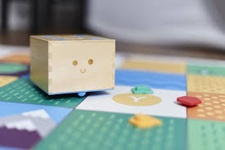  “I can redo my design.”  “I can persevere to finish.”  Strengths:  I feel I was really good at …  I want you to notice … |  | (insert photo/image here)    Stretches:  If I could change one thing, it would be …  because …

