OPTION #1 REMEDY REQUEST PROCEDURES

Login into your district Office 365, select Data Dashboard
Under Things to do….
Select Remedy
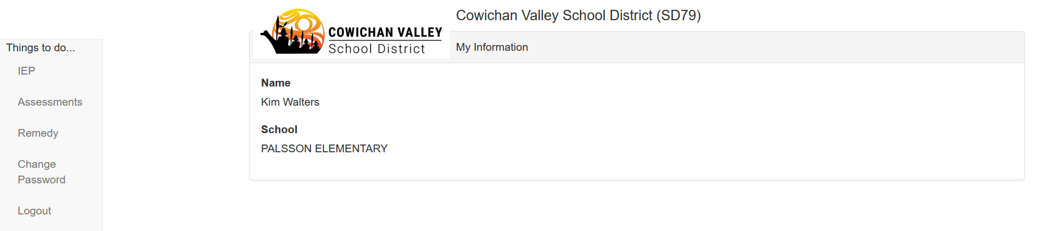

Available Remedy will appear at the top in the blue banner
Select “View Remedy Statement” for a statement of remedies earned and used
Select “+New Remedy Request”
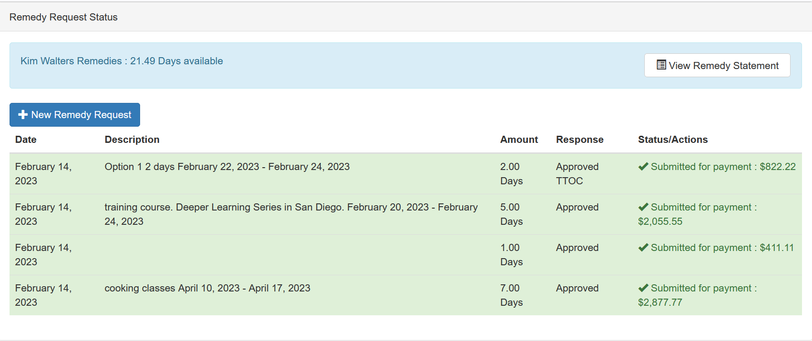

Enter an estimated amount (in days) for your remedy request
Select the dates of your absence
Please provide a description.
For LCTA members only, please select a reason for your request from the drop-down.
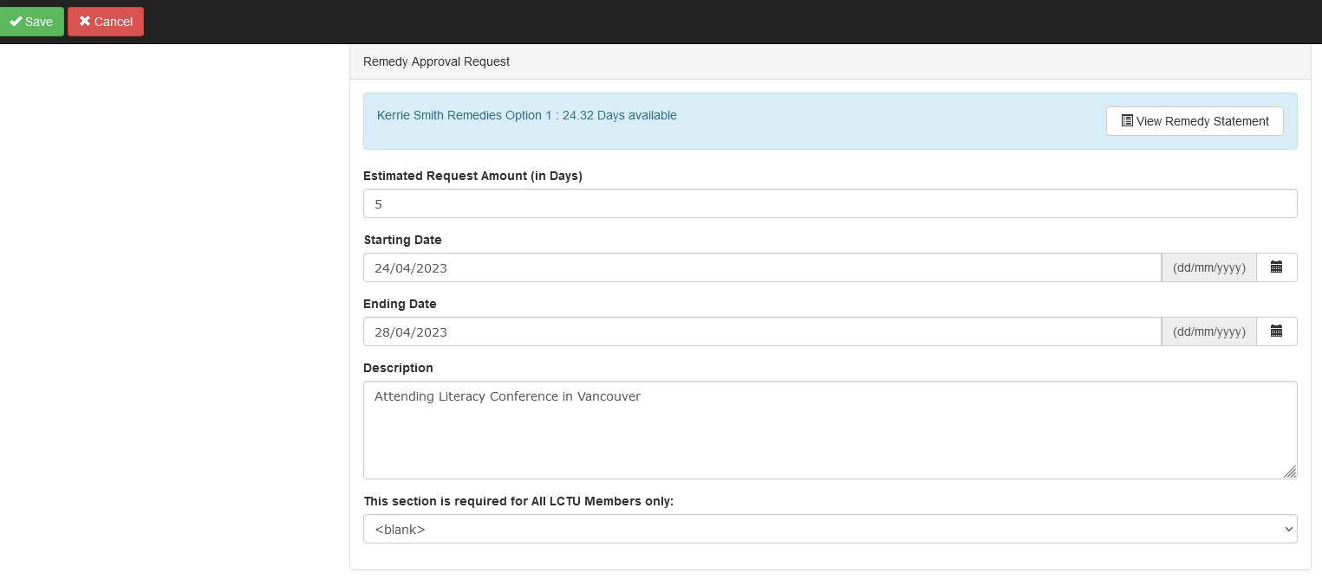

Select SAVE (top left corner)
Once saved, you will need to confirm the use of your request is 100% for teaching purposes. Please select “OK”.
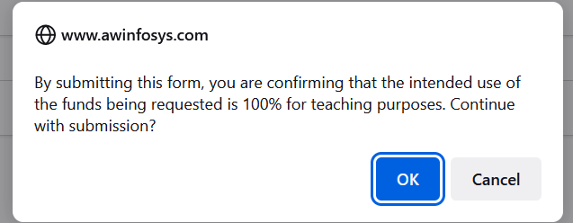

Once submitted, your request will appear as “In Review” until approved.

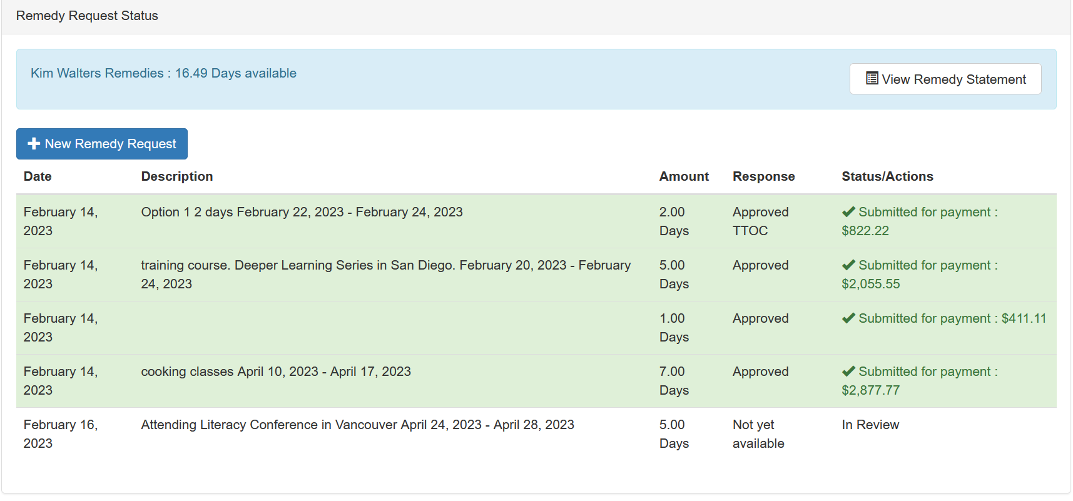
You will receive a notification once your request has been reviewed. Your request will either be Approved, Denied, or more information may be required. The “Response” column will indicate once your request has been approved. An email will also be sent to your school district email account.

Please ensure you record your absence with Dispatch.

