EASYCONNECT WILL NOT CALL YOU FOR DISPATCHES UNTIL YOU COMPLETE YOUR PREFRENCES

Welcome to EasyConnect’s automated dispatch system for offering and filling daily assignments. The following manual will assist you with getting set-up and answer questions you may have.

**log into your account on applytoeducation**

Visit <https://sd79-makeafuture.simplication.com/> and click the BOTTOM and not the top ‘Login using employee email address’ button and enter your School District email address to login.

**\*Update your Assignment Preferences**

1. In the **EasyConnect** section, select **‘Occasional Preferences’** and click **‘Edit Preferences’**
2. Check the **‘Willing to’** assignment boxes for assignments that you are wanting to be dispatched for
3. Check the **‘Selected Locations’** boxes for Locations you are wanting to be dispatched to

**\*TTOC’s and NHS ONLY**

**Assignment Offers vs. Job Board**

There are two different ways occasional employees can pick up daily supply assignments.

The first method is assignment offers. The EasyConnect system contacts occasional employees directly to offer them particular assignments. This is done based on the contact preferences set by the employee. Contact orders and calling windows are determined by the school district.

The second method is the job board. Occasional employees are not contacted directly for assignments on the job board. Rather, they must actively check the job board to view what is available.

**Update Your Preference of Accepting Assignments**

Update your ‘Contact Preferences’ for receiving assignment offers. You will have the choice of mobile app, phone, or text message. You will always receive an email.

|  |  |
| --- | --- |
| **Download the App** | Download the ApplyToEducation app from the app store. Login using your employee email address or username. Push notifications will be sent directly to your device when an assignment has been offered to you. |
| **Login from your phone, tablet or computer** | Log into your account and select EasyConnect – Offers from your EasyConnect section, click on the assignment you are interested in and click ‘Accept.’ |
| **Receive a Text** | After you receive an offer via text, sign into ApplyToEducation, select EasyConnect – Offers from your Occasional Employees section, click on the assignment you are interested in and click ‘Accept.’ Or Call EasyConnect and accept or decline the Assignment over the phone. |
| **Receive an Email** | Click on the link at the bottom of the email to sign into your ApplyToEducation account and accept or decline the Assignment. |
| **Receive a call from EasyConnect** | When prompted, enter your Employee ID number followed by the pound (#) key. Press 5 to accept or press 4 to decline. Press 2 to repeat the assignment details. |
| **Call EasyConnect at 1-855-279-3279** | Enter your school district code (79), employee ID and the pound (#) key. Assignments you were offered that are still available will be listed. |

**Job Board**

The Job Board is one of two ways to view and accept daily supply assignments. You are not directly contacted for assignments on the job board, but you are at liberty to accept any assignment you see there. It will only show you assignments that match the ‘Occasional Preferences’ you have set up. Otherwise, it will show all active assignments available based on the employee’s Occasional List.

*For dispatches that are accepted using the job board, the assignment hours will be updated depending on the start time of your attendance at the school, you may need to have the school contact dispatch at [dispatch@sd79.bc.ca](mailto:dispatch@sd79.bc.ca) to update the dispatch.

1. In the ‘EasyConnect’ menu, click ‘Job Board’ (see screenshot on page 2).A screenshot of a phone

   Description automatically generated
2. By default, you will see all available job postings for the rest of the school year. The total number of results are listed near the upper right (see #1 below). If so desired, you can refine the results, by several methods: selecting a more specific time frame (#2), entering keyword(s) (#3), or using the pre-set criteria on the left (#4).

*Note: the options on the left under ‘Narrow results by’ are based on the current assignments on the job board. In the example above, the only ‘Location’ is* ***‘Assumption’*** *because there is only one assignment currently on the job board, and that one assignment is in Assumption.*

1. Click on an assignment to view its ‘Assignment Details’ page.
2. If so desired, click **‘Accept’** at the bottom of the ‘Assignment Details’ page.

# **How to Know You Accepted an Assignment**

There are three main ways to confirm that you have accepted an assignment. These confirmations also occur when you are filled in for an assignment by a school board administrator.

1. A confirmation email is sent to the address listed on your ‘Occasional Preferences’ page. This confirmation email is also sent to the absent employee, as well as relevant school board administrators. An example confirmation email is seen below.

1. The accepted assignment is listed on the ‘Assignments Accepted’ page. Clicking on the assignment name will take you to the ‘Assignment Details’ page.

1. The accepted assignment is posted on the ‘My Calendar’ page. Clicking on an entry will show the **‘View Details’** button. Pressing this will take you to the ‘Assignment Details’ page.

There are a few other confirmation methods that are specific to a given acceptance method:

1. When accepting an assignment through the app, a pop-up will appear confirming the acceptance, and listing a confirmation number.
2. When accepting an assignment over the phone, the interactive voice response (IVR) system will provide verbal confirmation and a copy of the confirmation number.

**What if My EasyConnect Call is Accidentally Disconnected?**   
If your call is disconnected, please do one of the following:

1. Use the app to view and accept an assignment that was offered to you if it is still available.

2. Log into ApplyToEducation and under the **EasyConnect** section, select ‘**Assignments Offered’** and click **ACCEPT** if it is still available.

3. Call EasyConnect at 1-855-279-3279 and enter your School District’s Access Code and your Employee ID Number to access the opening. Only the assignments you were offered that are still available will be listed.

**Only Receive Assignment Offers Via Email**

You will always receive offers via email. On your ‘Occasional Preferences’ page, you then choose between one of three additional contact methods: mobile app, phone, or text message. However, you can have the system only offer assignments via email during certain timeframes.

1. In the ‘EasyConnect’ menu, click ‘My Calendar’.

1. Click **‘Only Offer Assignments Via Email’** at the bottom of the page.

1. Enter the information for the relevant timeframe. For a multi-day unavailability, click **‘Add Days’** on the left-hand side. It can be for part of the day, or the full day. When you are ready, click **‘Save’**.

For instance, you can set the system to only offer you assignments via email before or after a certain time of day. In the example below, if the occasional employee receives an assignment offer before 8:30AM, it will only be sent via email. For offers later than 8:30AM, the occasional employee will receive an email as well as a phone call, text message, or app notification (as specified on the ‘Occasional Preferences’ menu)

1. A screen shot of a message

   Description automatically generatedOnce you have saved your event, you will be returned to the ‘My Calendar’ page where you can view it and all other events you have entered. Clicking on any instance of the event will show its details, as well as the options **‘Edit this event’** and **‘Delete this event’**. You can click either of those buttons to edit or delete the entire event.

**Do Not Disturb**

Do Not Disturb is used to silence the app notifications, calls, and text messages for the time frame you select. However, you will still receive offers via email.

* 1. Click the **Do Not Disturb** button.

* 1. Select the Dates and Times you would like to silence the app notifications, calls, and text messages

Option to Click Add Days to create a time frame. 

c. Click **Save**. You can **Edit** or **Delete** the date and times you have entered for the DND at any time.

# **Inputting an *Unavailability**

**\*CUPE ONLY** - PLEASE NOTE THAT IF YOUR UNAVAILABILITY IS LONGER THAN TWO WEEKS, YOU MUST SUBMIT AN EMAIL REQUEST TO HRCUPEUSW@SD79.BC.CA THREE WEEKS PRIOR TO THE REQUESTED TIME OFF.

Avoid receiving Assignment Offers for days you are not available by selecting **‘My Calendar’**, from the **EasyConnect** section, selecting ‘**Dates Not Available**’ and entering dates you cannot work.

***If you’re in an Temporary Assignment you must also enter the dates into the calendar as they are not automatically inputted.*** Any Changes you make will be “live” immediately.

You are considered Available unless you mark yourself as Unavailable in the calendar. You will not receive Assignment Offers for timeframes in which you are Unavailable. Not keeping the calendar up-to-date with your unavailability can lead to a refusal (**CUPE ONLY** 10 refusals in a school year is cause for termination).

1. In the ‘EasyConnect’ menu, click ‘My Calendar’.

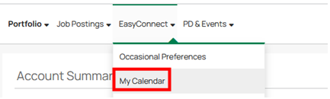

1. Click **‘Dates Not Available’** at the bottom of the page.

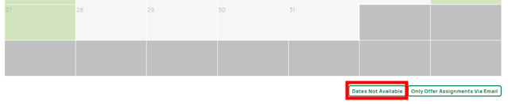

1. Enter the information for the relevant timeframe. For a multi-day unavailability, click **‘Add Days’** on the left-hand side. The availability can be for part of the day, or the full day. When you are ready, click **‘Save’**.

*In the example above, the occasional employee is putting in an Unavailability for every Monday, Wednesday, and Friday for the months of September-December. Thus, this employee will only receive offers for assignments occurring on Tuesdays and Thursdays.*

1. Once you have saved your unavailability, you will be returned to the ‘My Calendar’ page where you can view your event(s).

You can click on any instance of the event to view the options **‘Edit this event’** and **‘Delete this event’**. Such actions will affect all days of a multi-day absence.

1. for part of the day, or the full day. When you are ready, click **‘Save’**.

**How to Cancel an Accepted Assignment**

**NOTE**: IF YOU DO NOT SEE THE ABILITY TO CANCEL AN ASSIGNMENT YOU SHOULD EMAIL [DISPATCH@SD79.BC.CA](mailto:DISPATCH@SD79.BC.CA) ASAP TO ASSIST WITH CANCELLING YOUR ACCEPTED ASSIGNMENT.

1. In the ‘EasyConnect’ menu, click ‘Assignments Accepted’.
2. Click on the name of the relevant assignment.

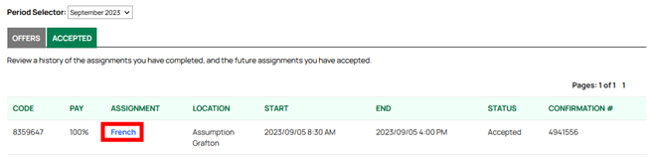

1. This will bring you to the ‘Assignment Details’ page.

The cancellation option is found at the bottom of this page.

1. Enter the reason for the cancellation, then click **‘Confirm Cancellation’**.

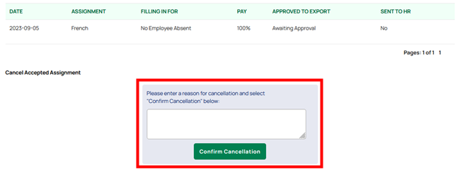

You will receive a pop-up notification of the cancellation. An email will then be sent to you, the absent employee, and all relevant school board administrators, confirming the cancellation.

If relevant, EasyConnect will recommence contacting available replacements to fill the now vacant assignment.

***Note: If cancelling a dispatch, you will be blocked from picking up new assignments on the same day as an assignment you have cancelled. You will be able to pick up assignment from the Job Board.***