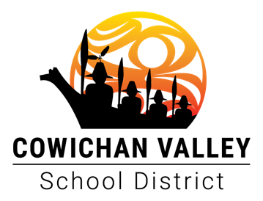

2022 – 2023 Budget Development
Spring of 2022

When | Who | What
Tuesday, February 22nd | Regular Board Education & Business Committee | Review 2022/2023 Budget Assumptions.  Establish 2022/2023 Budget Guiding Principles
Tuesday, March 1st | Regular Board Meeting | Adoption of 2022/2023 Budget Guiding Principles
Tuesday, March 15th | J Sandquist/ Province | Ministry Funding Announcement.
Tuesday, March 29th | Regular Board Education & Business Committee | Review Ministry formula and funding announcement and begin to develop options.
Friday, April 1st | Senior Staff/ Trustees | Online survey in school newsletters and on website.
Tuesday, April 5th | Regular Board Meeting | Update the Board on Budget Progress
Friday, April 8th  1 pm - | Partner Group Liaison Meetings | Trustees to meet with Partner Groups.
Thursday, April 14th | Special Board Education & Business Committee | Review of funding and options.
Sunday, April 17th | Senior Staff/ Trustees | Online Survey deadline for input.
Tuesday, April 19th  4:30 – 5:30 pm | Advisory Committee Meeting | Review of funding announcement with the Advisory Committee, seeking feedback and perspectives.
Tuesday, April 19th ^{t}  5:30 – 6:30 pm | Senior Staff/Trustees | Opportunity for public to provide input on the budget.
April 21st – 24th | Board | BCSTA AGM
Tuesday, April 26th | Regular Board Education & Business Committee | Review feedback received; explore options; develop budget drafting instructions.
Thursday April 28th | Special Board Education & Business Committee | Recommend budget to the Board.
Tuesday, May 3rd | Regular Board Meeting | 1st and 2nd reading of budget bylaw.
Wednesday, May 4th | Staff | Staffing assignments initiated.
Tuesday, June 7th | Regular Board Meeting | 3rd reading of budget bylaw.

