TEACHERS: Make a copy and share with families for supplemental resources, if you like. Answer Key (when possible) is located on the last page.

Student Directions:
Looking for an extra challenge? Want some fun math to do? Check out this Choice Board that you can complete at home. This is not part of your 30-minutes of Teacher-Led Learning, so it’s completely optional! Challenge yourself to think like a mathematician and ask yourself the following questions:
- What do I notice? What do I wonder? What questions could I answer using mathematics?
- How could I explain my thinking to someone in my family?
- Do I notice any patterns?
- How does this task connect to something I have learned previously in math class?

Each of the tasks are organized into tables below. As you complete a task, cross out or star the problem on the board below. Can you get 3 in-a-row? Try for an “X” or a “+” if you find tasks that you like.

Algebra 1 Choice Board- April 27

Lock Puzzle | Temperature Function | Fraction Talk
Car Travel | Percent Change | Triangle Sum Puzzle
Matilda’s Multiplication | Weighing Pets | Which One Doesn’t Belong?

Lock Puzzle  (@MrsCookMSMath)  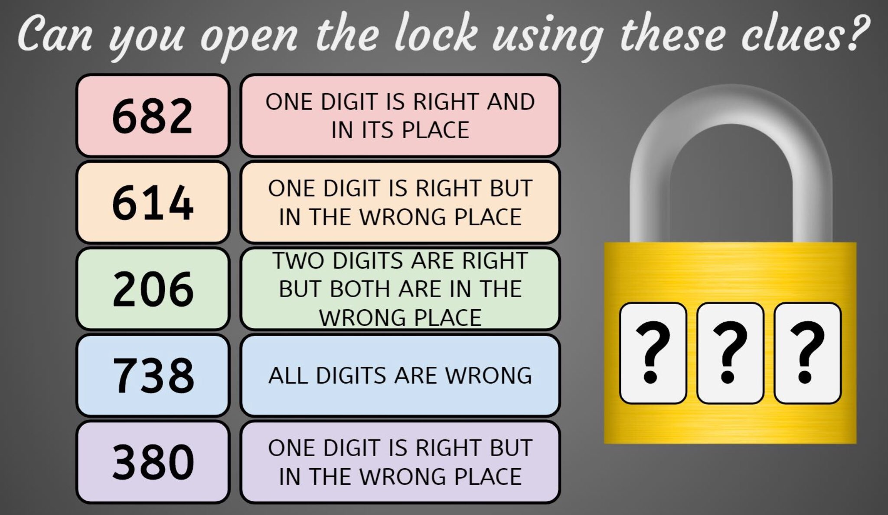 | Temperature Function  (https://im.kendallhunt.com -AlgU5PA#9)  The function $g$ represents the temperature in a city, in degrees Fahrenheit, $h$hours after 8:00am. The graph plots some values of $g$:  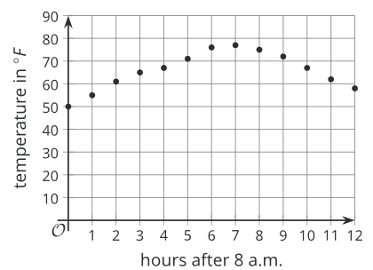  Select all statements that must be true about the situation.  - $g(0)=50$  - $g(12)$ represents the temperature at noon.  - $g(11)<g(8)$  - The temperature increased by about 10 degrees Fahrenheit between 8:00am and 1:00pm.
Weighing Pets
( https://brilliant.org/)
What weight will the fourth scale display?
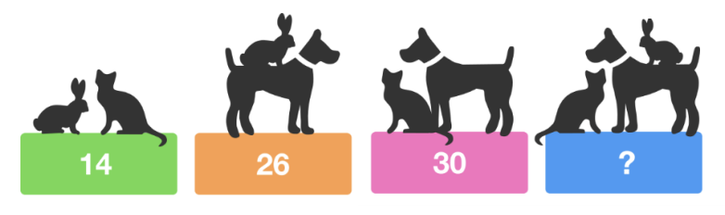
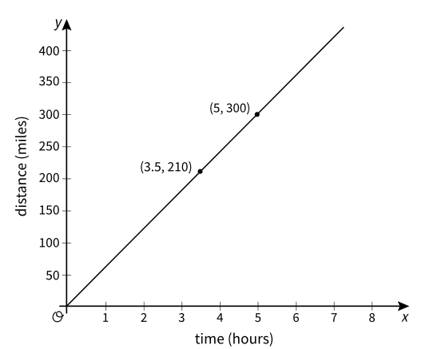
Car Travel
(openupresources.org - 8U2PA#4)
A car traveled at a constant speed. The graph shows how far the car traveled, in miles, during a given amount of time, in hours.
- The point
- $(3.5, 210)$ is on the graph. Explain what this means in terms of the car.
- Is the point $(1,60)$ on this graph? Explain how you know.

Fraction Talks  (http://fractiontalks.com/how-to/)  What fraction of the square is yellow? How do you know?  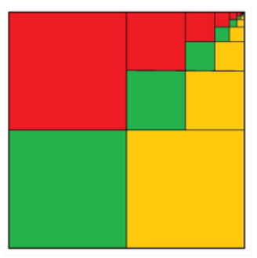 | Triangle Sum Puzzle  (@Logicandmaths)  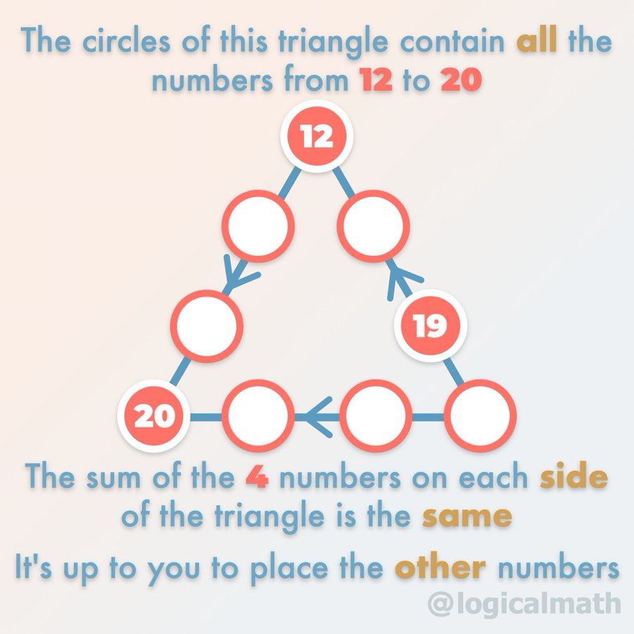
Matilda’s Multiplication  (@logicandmaths)  Matilda multiplied a 4-digit number by 6, but seven of the digits in the multiplication have blown away and can be seen under it. But beware: a 6 and a 9 can appear identical after they have been blown away.  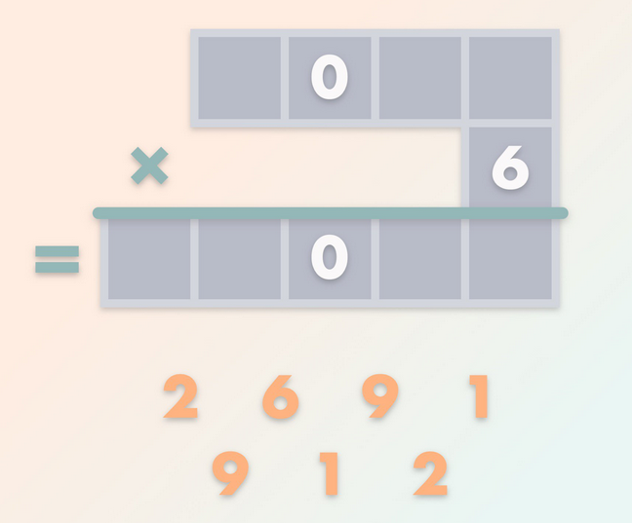  What was the result of the multiplication? | Which One Doesn’t Belong?  (https://wodb.ca/)  Which one doesn’t belong? Can you think of a reason why each one doesn’t belong in their own way?  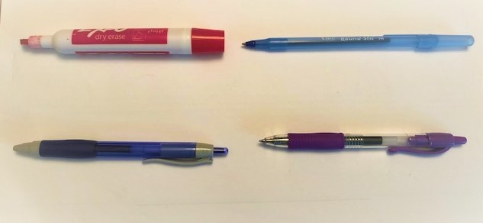
Percent Change
(https://im.kendallhunt.com -AlgU5PA#7)
Solve each problem below. Can you use a visual or diagram to help you see it?
- A child ate 30 grams of cereal for breakfast and her brother ate 40% more than that. How many grams of cereal did the brother eat?
- A pair of shoes that normally cost $30 have their price reduced by 25%. What is the sale price of the shoes?

KEY
Algebra 1 -April 27 - KEY

Lock Puzzle  I think one possible answer is “042” -- might be more and I might be wrong :) | Temperature Function  Statements A, C, and D | Fraction Talk  1/3
Car Travel  - It means that after 3.5 hours, the car has traveled a distance of 210 miles.  - Yes, the car is traveling at a constant speed, and 300 miles in 5 hours means the car travels 60 miles each hour. That means the point is on the graph. | Percent Change  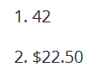 | Triangle Sum Puzzle  Video Solution: 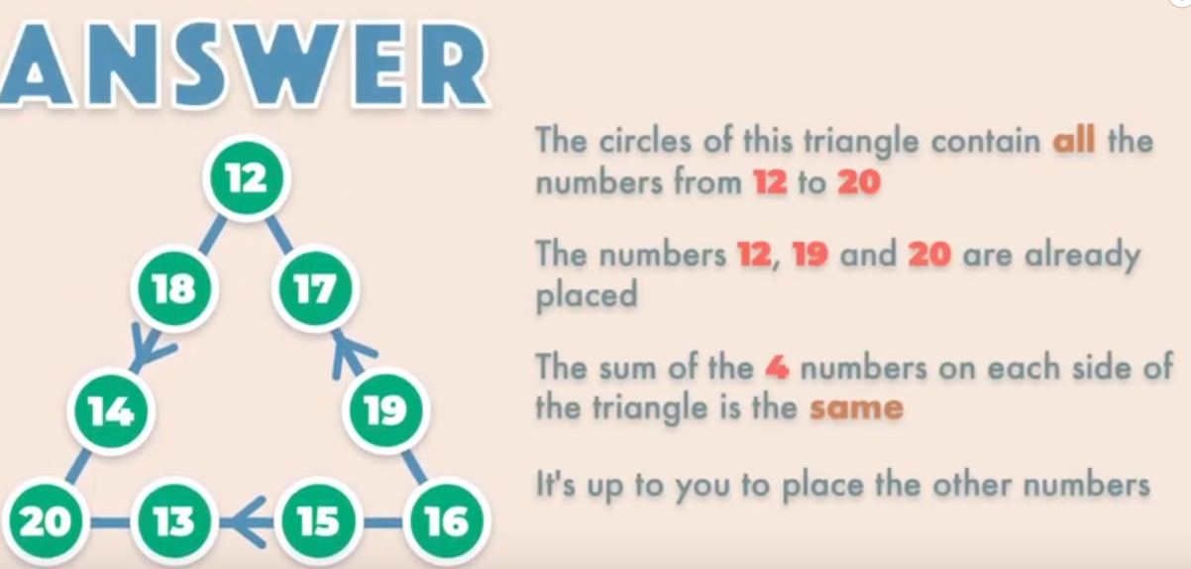
Matilda’s Multiplication  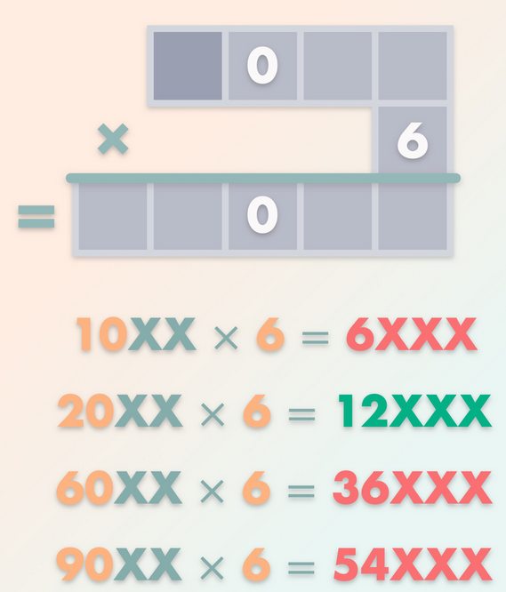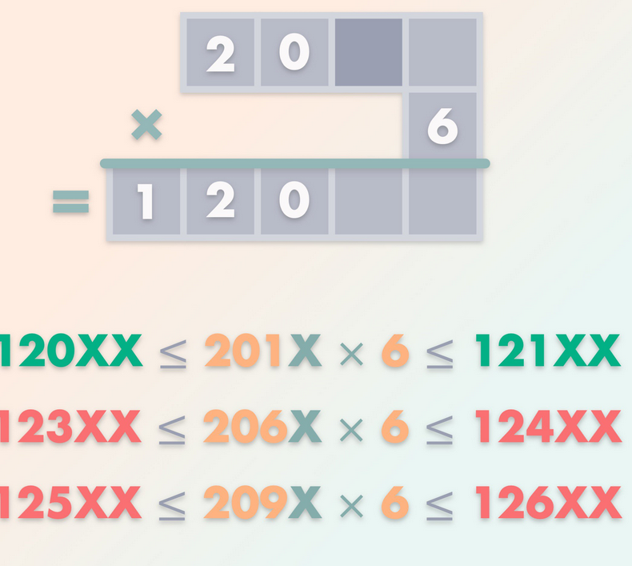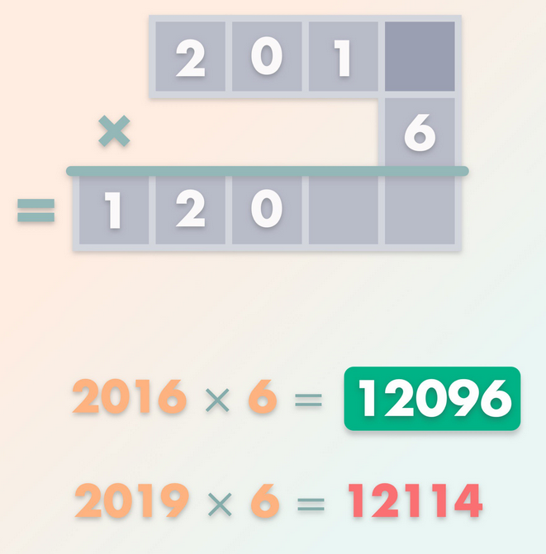 | Weighing Pets  The fourth scale will display 35 (rabbit =5, cat =9, dog=21) | Which One Doesn’t Belong?  Answers vary

