TEACHERS: Make a copy and share with families for supplemental resources, if you like. Answer Key (when possible) is located on the last page.

Student Directions:
Looking for an extra challenge? Want some fun math to do? Check out this Choice Board that you can complete at home. This is not part of your 30-minutes of Teacher-Led Learning, so it’s completely optional! Challenge yourself to think like a mathematician and ask yourself the following questions:
- What do I notice? What do I wonder? What questions could I answer using mathematics?
- How could I explain my thinking to someone in my family?
- Do I notice any patterns?
- How does this task connect to something I have learned previously in math class?

Each of the tasks are organized into tables below. As you complete a task, cross out or star the problem on the board below. Can you get 3 in-a-row? Try for an “X” or a “+” if you find tasks that you like.

Math 6 Choice Board- April 27

Lock Puzzle | Distance Runners | Fraction Talk
Representing Numbers | Painting a Fence | Triangle Sum Puzzle
Matilda’s Multiplication | Weighing Pets | Which One Doesn’t Belong?

Lock Puzzle  (@MrsCookMSMath)  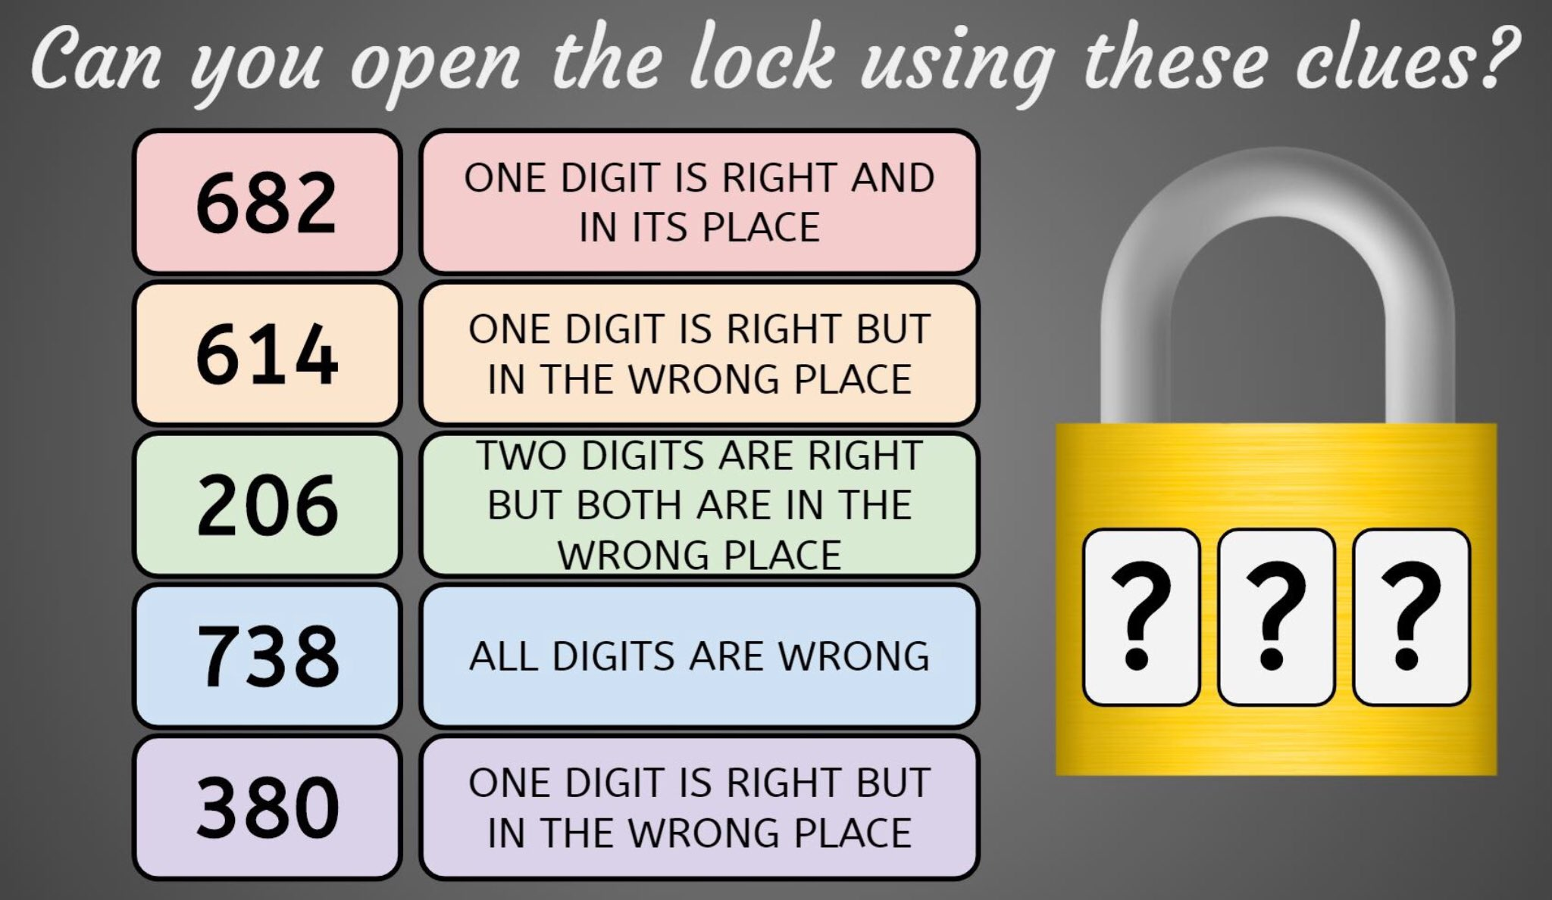 | Distance Runners  (openupresources.org - 6U5MUA#4)  Four runners are training for long races. Noah ran 5.123 miles, Andre ran 6.34 miles, Jada ran 7.1 miles, and Diego ran 8 miles.  - What is the total running distance of the four runners?  - Jada ran how much farther than Noah?
Matilda’s Multiplication  (@logicandmaths)  Matilda multiplied a 4-digit number by 6, but seven of the digits in the multiplication have blown away and can be seen under it. But beware: a 6 and a 9 can appear identical after they have been blown away.  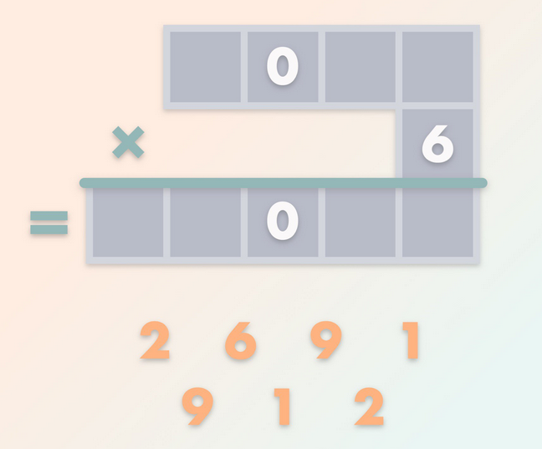  What was the result of the multiplication? | Representing Numbers  (openupresources.org - 6U5PA#1)  Take a moment to look at the diagram below:  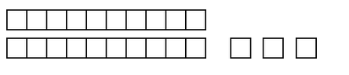  - Jada says this diagram can represent 230. What does a small square represent for Jada?  - Name a number greater than 230 that this diagram can also represent.  - Name a number smaller than 230 that this diagram can also represent.  BONUS: Can you describe a rule or pattern that a number must follow in order to be represented by this diagram?

Painting a Fence  (openupresources.org -6U4MUA# 7)  Tyler used gallons of paint to paint a fence. How  many gallons will it take to paint the whole fence?  Write a multiplication equation or a division  equation to represent this question, then find the answer using a tape diagram. | Triangle Sum Puzzle  (@Logicandmaths)  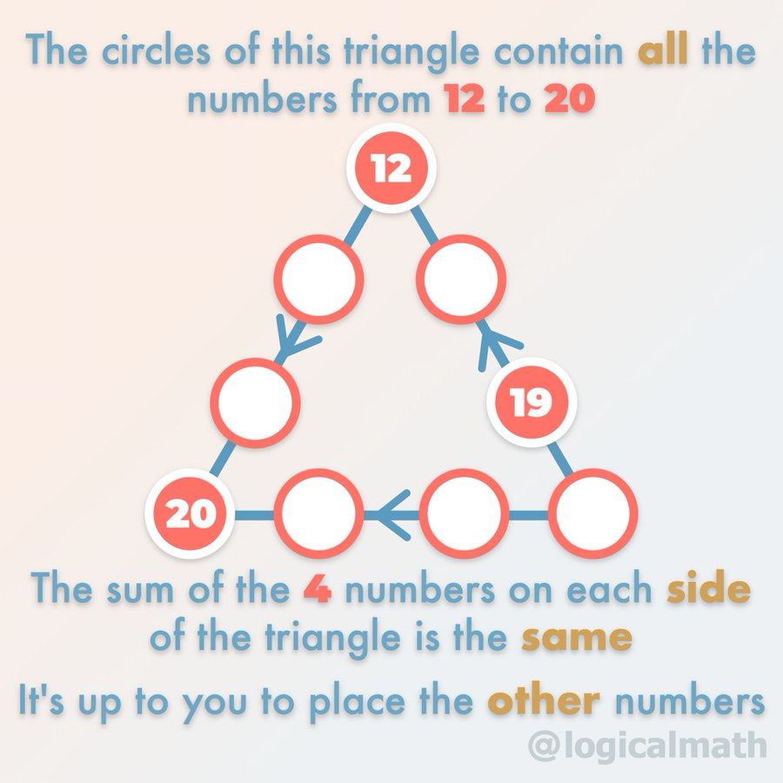
Weighing Pets
(https://brilliant.org/)
What weight will the fourth scale display?
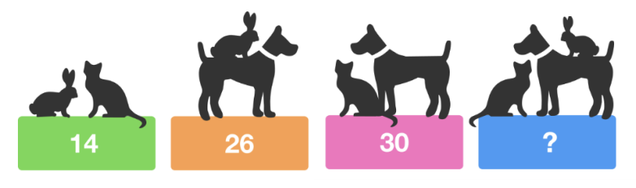

Fraction Talks  (http://fractiontalks.com/how-to/)  What fraction of the manipulatives are yellow? How do you know?  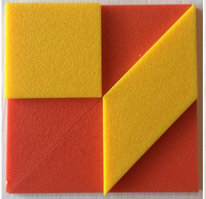 | Which One Doesn’t Belong?  (https://wodb.ca/)  Which one doesn’t belong? Can you think of a reason why each one doesn’t belong in their own way?  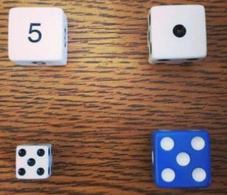

KEY
Math 6 -April 27 - KEY

Lock Puzzle  I think one possible answer is “042” -- might be more and I might be wrong :) | Distance Runners  - 26.563 miles  - 1.977 miles | Fraction Talk  ½ or 4/8
Representing Numbers  - 10  - Answers vary. Sample responses: 2,300; 23,000; 230,000; 460  - Answers vary. Sample responses: 0.23; 0.023; 0.0023; 1.15 | Painting a Fence  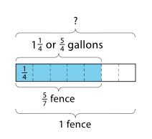 | Triangle Sum Puzzle  Video Solution: 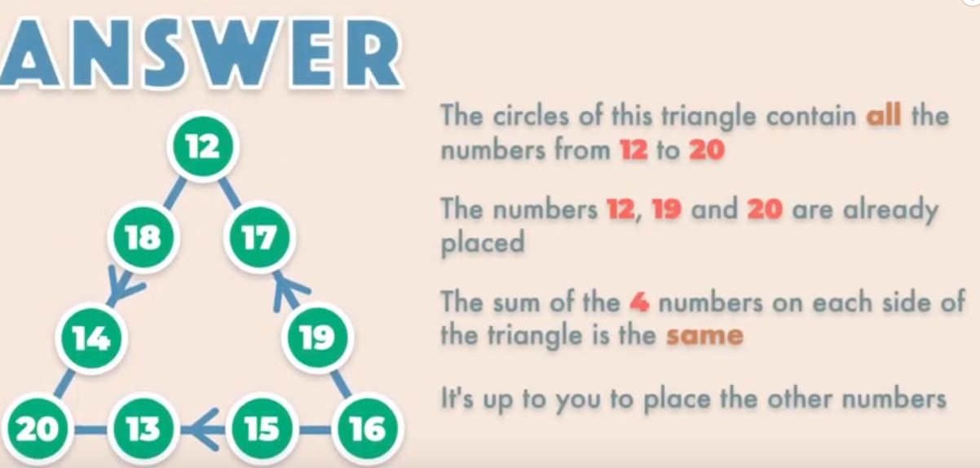
Matilda’s Multiplication  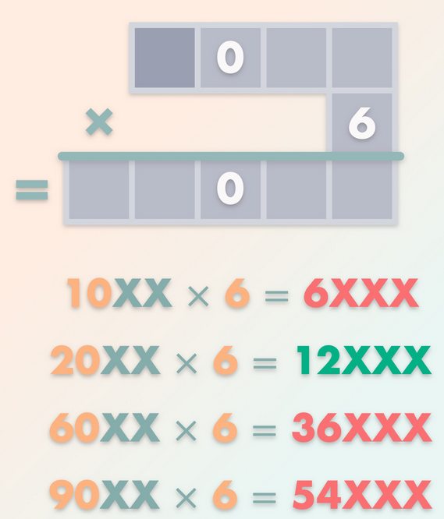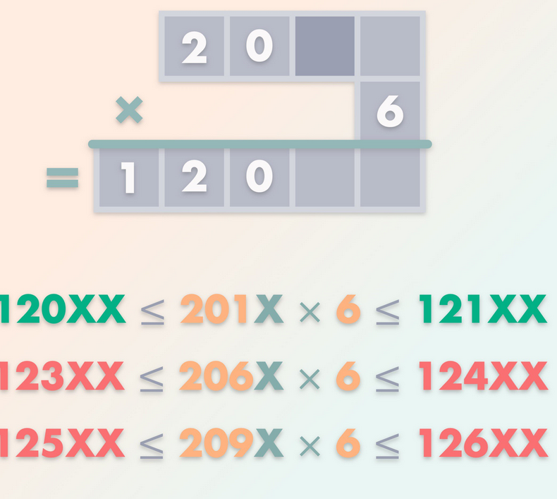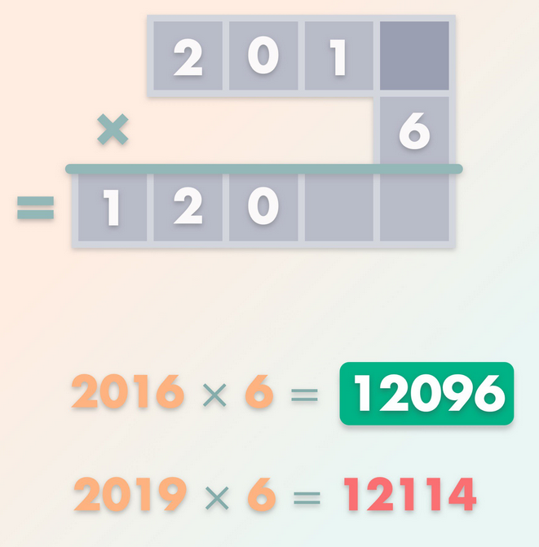 | Weighing Pets  The fourth scale will display 35 (rabbit =5, cat =9, dog=21) | Which One Doesn’t Belong?  Answers vary

