TEACHERS: Make a copy and share with families for supplemental resources, if you like. Answer Key (when possible) is located on the last page.

Student Directions:
Looking for an extra challenge? Want some fun math to do? Check out this Choice Board that you can complete at home. This is not part of your 30-minutes of Teacher-Led Learning, so it’s completely optional! Challenge yourself to think like a mathematician and ask yourself the following questions:
- What do I notice? What do I wonder? What questions could I answer using mathematics?
- How could I explain my thinking to someone in my family?
- Do I notice any patterns?
- How does this task connect to something I have learned previously in math class?

Each of the tasks are organized into tables below. As you complete a task, cross out or star the problem on the board below. Can you get 3 in-a-row? Try for an “X” or a “+” if you find tasks that you like.
Math 7 Choice Board- April 27

Lock Puzzle | Match the Graph | Fraction Talk
Hippos and Crocodiles | Area of Shapes | Triangle Sum Puzzle
Matilda’s Multiplication | Weighing Pets | Which One Doesn’t Belong?

Lock Puzzle  (@MrsCookMSMath)  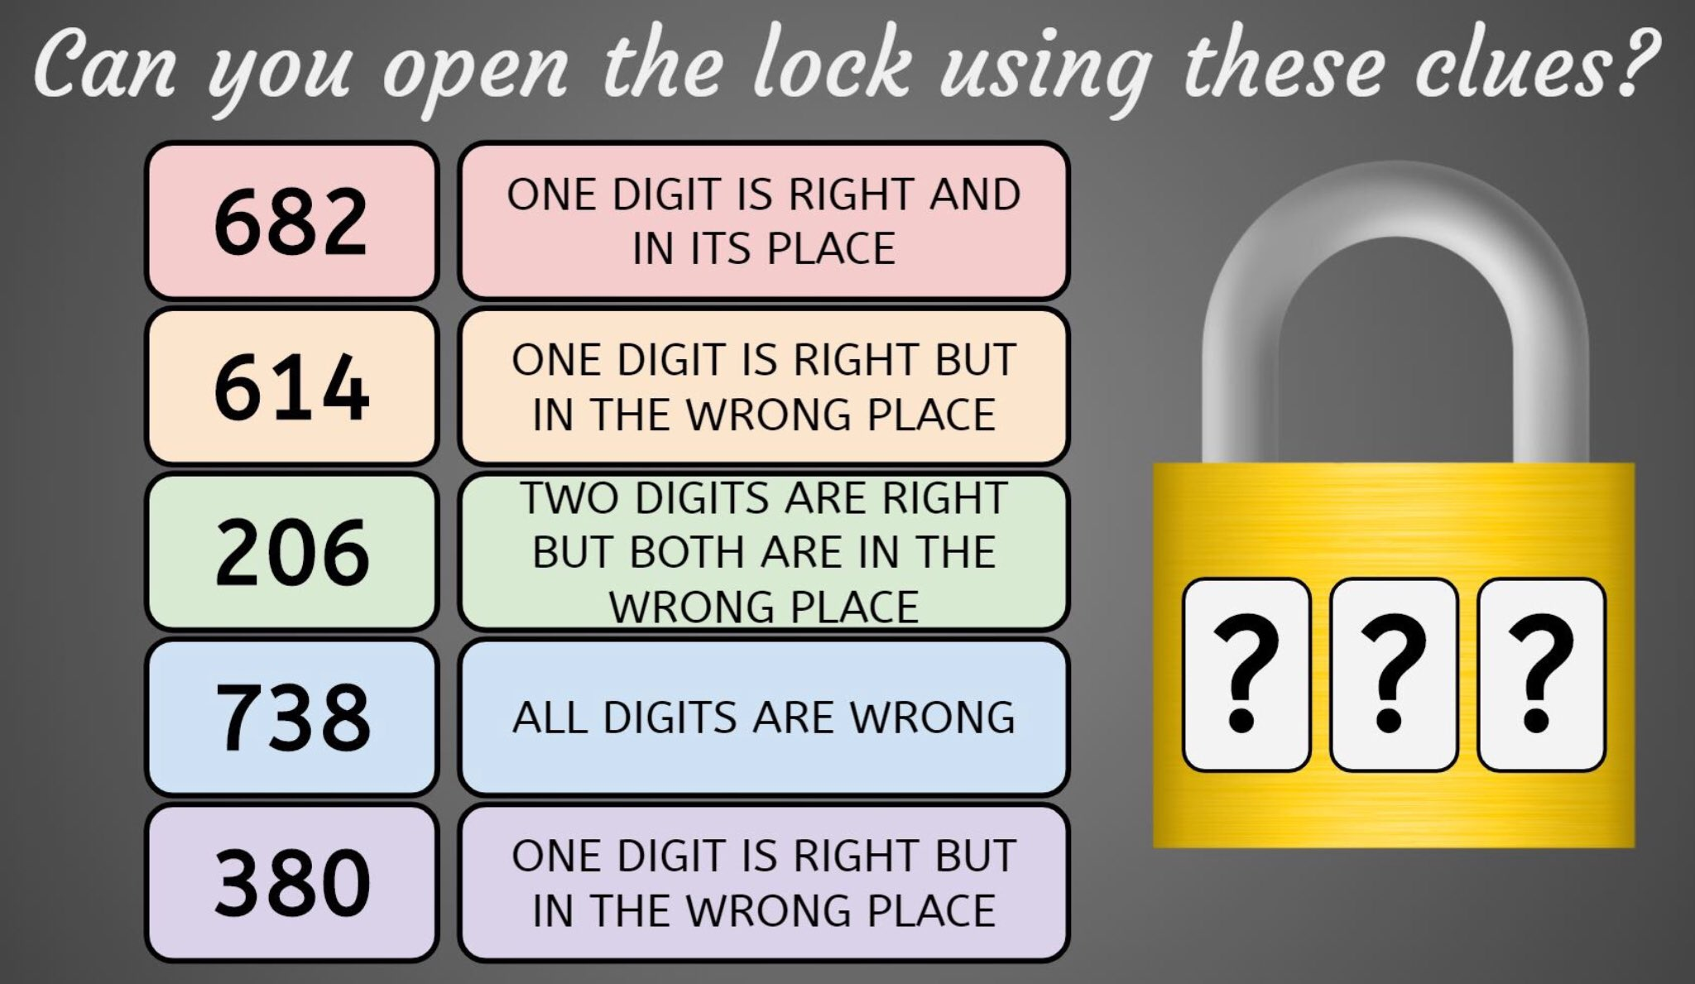 | Match the Graph  (openupresources.org - U2EUA#1)  Which graph represents a proportional relationship? Explain your reasoning.  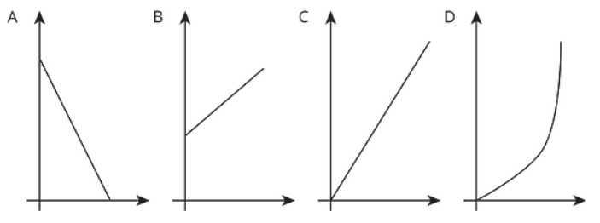
Matilda’s Multiplication  (@logicandmaths)  Matilda multiplied a 4-digit number by 6, but seven of the digits in the multiplication have blown away and can be seen under it. But beware: a 6 and a 9 can appear identical after they have been blown away.  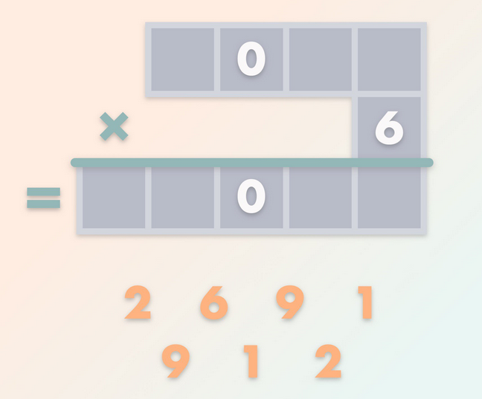  What was the result of the multiplication? | Hippos and Crocodiles  (openupresources.org - 7U2PA#5)  The ratio of the number of hippos to the number of crocodiles at a watering hole is $4:3$ . Draw a double number line diagram that would show the number of crocodiles if there were 20 hippos.  A blank double number line is provided for you here if you want to use it:  BONUS: Can you solve this problem using a different method?

Area of Shapes  (openupresources.org -U1PA#4)  Each small square in the graph paper represents 1 square unit. Find the area of each figure. Explain your reasoning.  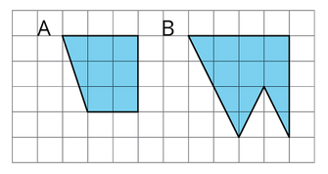 | Triangle Sum Puzzle  (@Logicandmaths)  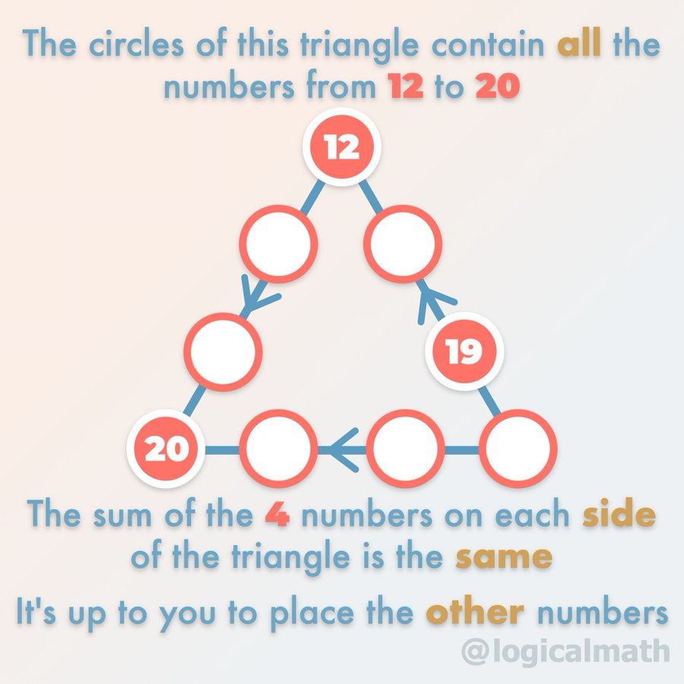
Weighing Pets
( https://brilliant.org/)
What weight will the fourth scale display?
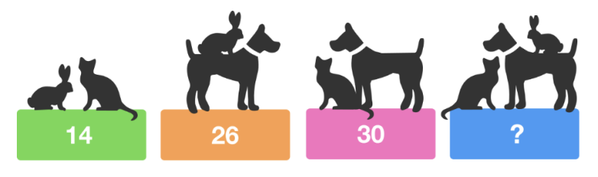

Fraction Talks  (http://fractiontalks.com/how-to/)  What fraction of the square is yellow? How do you know?  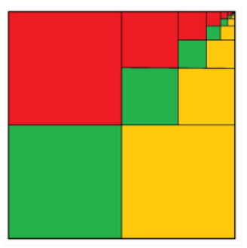 | Which One Doesn’t Belong?  (https://wodb.ca/)  Which one doesn’t belong? Can you think of a reason why each one doesn’t belong in their own way?  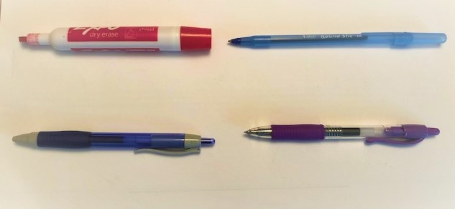

KEY
Math 7 -April 27 - KEY

Lock Puzzle  I think one possible answer is “042” -- might be more and I might be wrong :) | Match the Graph  Graph C | Fraction Talk  1/3
Hippos and Crocodiles  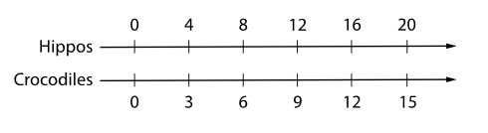 | Area of Shapes  Figure A has an area of 7 ½ square units. It can be divided into a 2-unit-by-3-unit rectangle (with an area of 6 square units) and a 1-unit-by-3-unit triangle (with an area of 1 ½ square units). Figure B has area of 10 square units. It can be surrounded by a 4-unit-by-4-unit square with two triangles removed. Those triangles have areas of 4 and 2. The area of Figure B is 10 square units since 16-4-2=10 . | Triangle Sum Puzzle  Video Solution: 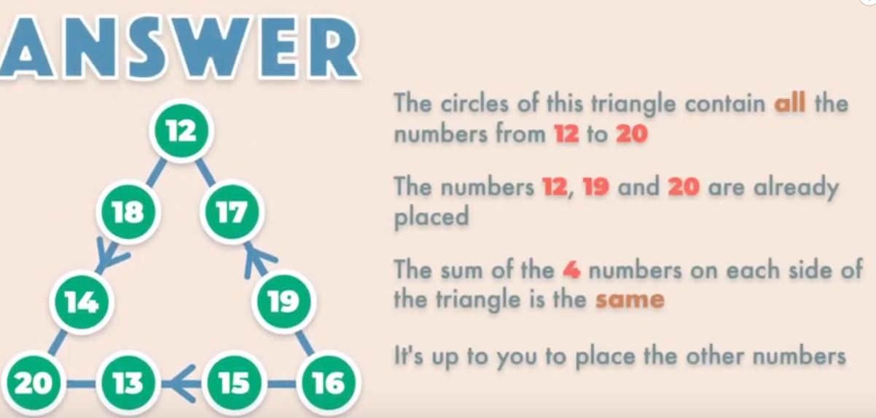
Matilda’s Multiplication  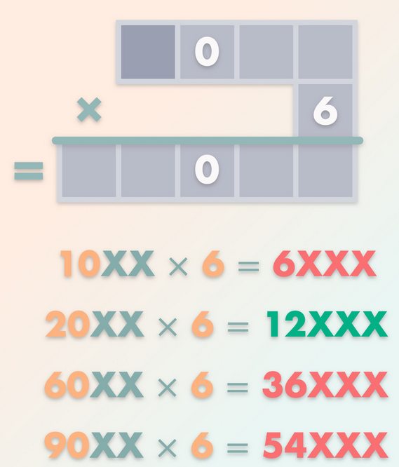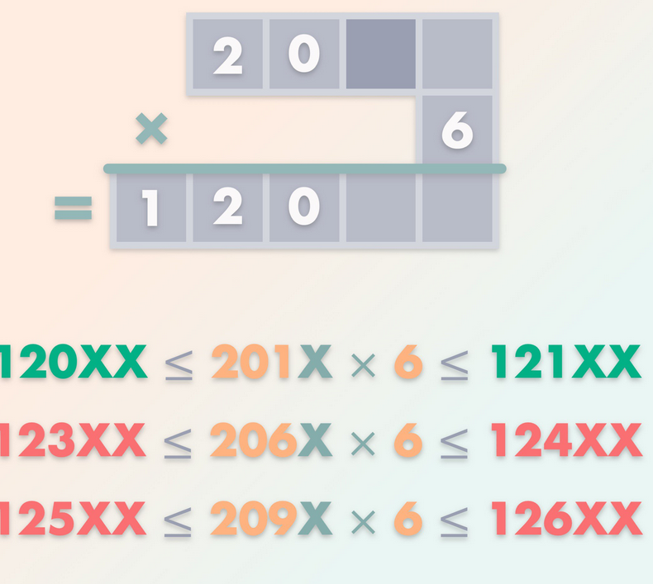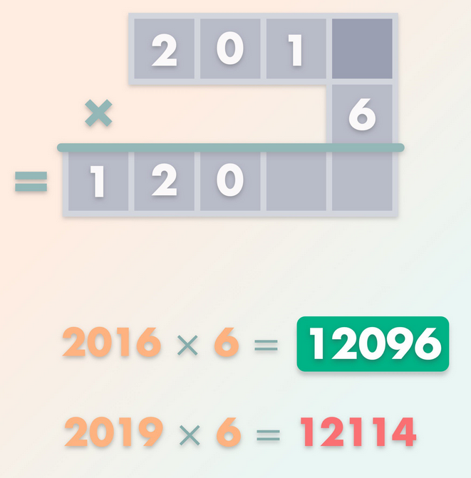 | Weighing Pets  The fourth scale will display 35 (rabbit =5, cat =9, dog=21) | Which One Doesn’t Belong?  Answers vary

