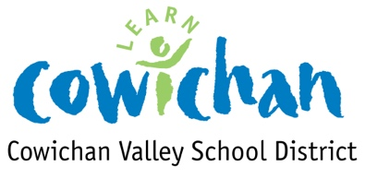
Cowichan Valley School District Stage 3 Plan
The Ministry of Education has a five-stage approach for resuming in-class instruction in a measured way to align with B.C.’s Restart Plan. Each stage will be guided by health and safety guidelines, measures, protocols and orders as well as the principles developed for continuity of learning during the pandemic:

Maintain a healthy and safe environment for all students, families and employees
Provide the services needed to support the children of our essential workers (ESWs)
Support vulnerable students who may need special assistance
Provide continuity of educational opportunities for all students
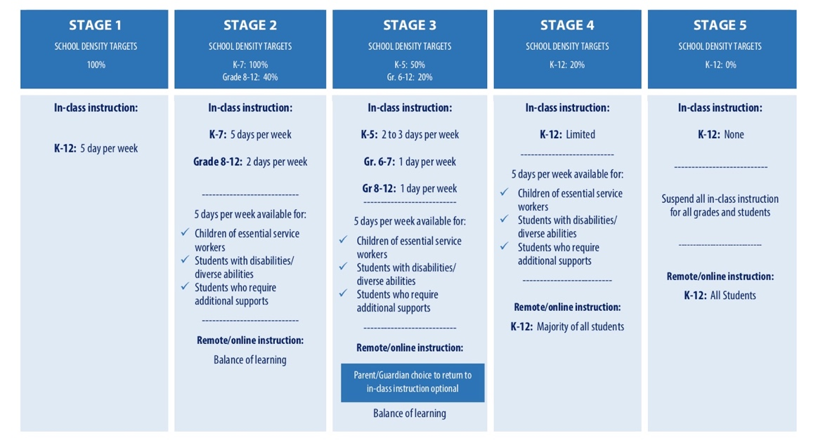

As part of B.C.’s Restart Plan, the focus for the K-12 sector is to increase in-class instruction in a gradual and controlled manner while ensuring health and safety measures to reduce the risk of Covid-19 transmission are in place. School density targets have been established to ensure the number of students in the K-12 environment is manageable and aligns with public health guidance.
- Guidelines established for the K-12 sector:
  - Grades K-5 (2days per week)
  - Grades 6 – 12 (1 day per week)
  - 5 days week available for children of Essential Service Workers, students with disabilities/ diverse abilities, and students requiring additional supports.
  - Note: teachers, administrators and support staff should be considered ESWs.
- School districts will organize their daily and weekly schedules based on school density targets and the number of children who are choosing to return to in-class instruction.
Cowichan Valley School District Guidelines for Developing Stage 3 plans

- Teaching staff will collaborate in the development of school plans
- Participation of K-5 students will not exceed 50% of school density on any given day
- Participation of gr 6-12 students will not exceed 20% of school density on any given day
- Schools will determine which day(s) work best for remote learning
- At Elementary, ESW students have the option to attend all week
- Vulnerable learners will continue to receive additional support, up to 5 days day per week
- Keep families together on their attending school days
- Try to keep friends within each class/group together as much as possible
- Teachers will not have students in front of them on their remote learning day
- Non-enrolling will provide support where possible and/or when needed
- Try to create family or cohort groupings to limit the movement of students and teachers
- Reduce the number of classrooms in use during the day to allow for additional cleaning
- Lunches will be available where needed, with additional health and safety, and hygiene measures in place. Meal pick up will continue for students not in attendance.

Elementary Framework

- K-5 students should be divided into two groups (Group A and Group B). They will attend on two consecutive days
- Grade 6 and 7 students should be divided into two groups and will each attend on one day. Schools are to determine which days are best to have the 6-7 students attend
- Staffs will collaboratively determine who will be with ESW students and ‘vulnerable’ learners who have the option to attend all week, recognizing that classroom teachers will not be utilized for this on remote learning days.
- Teachers will have their own students including vulnerable and ESW students on non-remote learning days

Secondary Framework

- All students will receive 1 day of in class support per week
- Teachers will be available to support face to face learning approximately 2 days of the week
- Grouping will be created by grades, pods within grades or alpha
- There will not be any block tumbles. Students will remain together in one cohort in the morning and may change into a new cohort for the afternoon
- Possibly morning academics and afternoon electives
- Maximum of 1 change per day for students. Minimize room usage
- Classroom sessions will be to support the learning occurring at home
- Online learning will continue to be ongoing throughout the week
- Electives will be offered where possible

Increased Health and Safety Measures

- Schools will implement staggered drop off and pickup times and modify lunch and recess hours to reduce congestion and large groupings.
- Schools will organize students and teachers into co-horts that stay together – minimize amount of mixing between students and different staff throughout the day.
- Teachers will take students outside as often as possible
- Schools will be cleaned more frequently, including high touch areas.
- Schools will place limitations on assemblies and other large gatherings
- Students will be asked to wash their hands frequently, including before coming to school.
- Students will be asked to not to share their personal items, food or drinks
- Parents will be asked to monitor their children daily for symptoms and not to send them to school if they are sick. People who are sick will not be allowed in school.
- Parents will be asked to remind children to minimize physical contact with their friends.

