OPTION #4 REMEDY REQUEST & REIMBURSEMENT PROCEDURES

Login into your district Office 365, select the Data Dashboard
Under Things to do…
Select Remedy
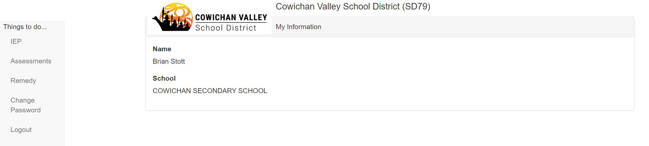

Available Remedy will appear at the top in the blue banner
Select “View Remedy Statement” for a statement of remedies earned and used
Select “+New Remedy Request”
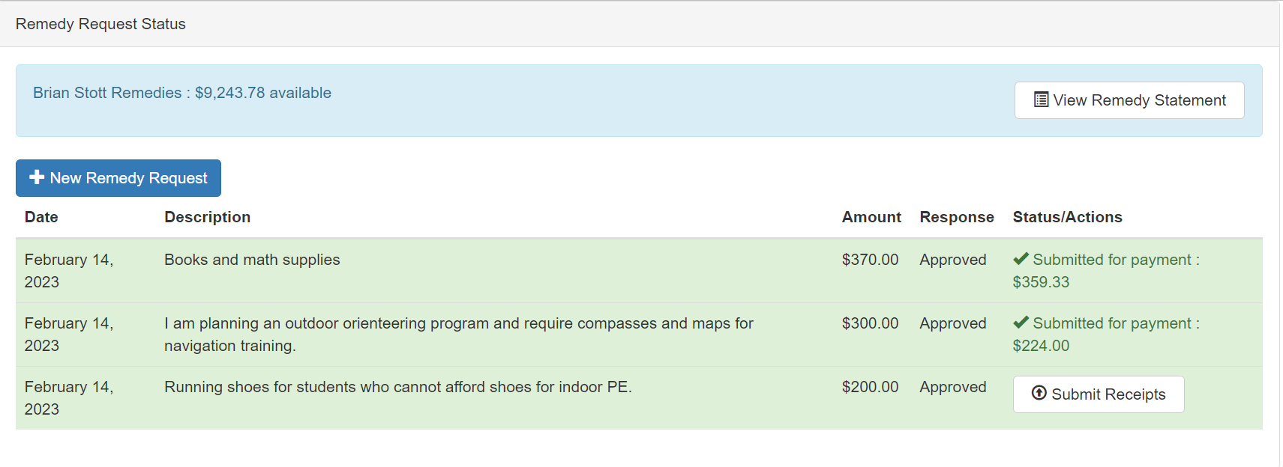

Enter an estimated amount (in dollars) for your remedy request.
Provide a description of how your request will directly benefit your students.
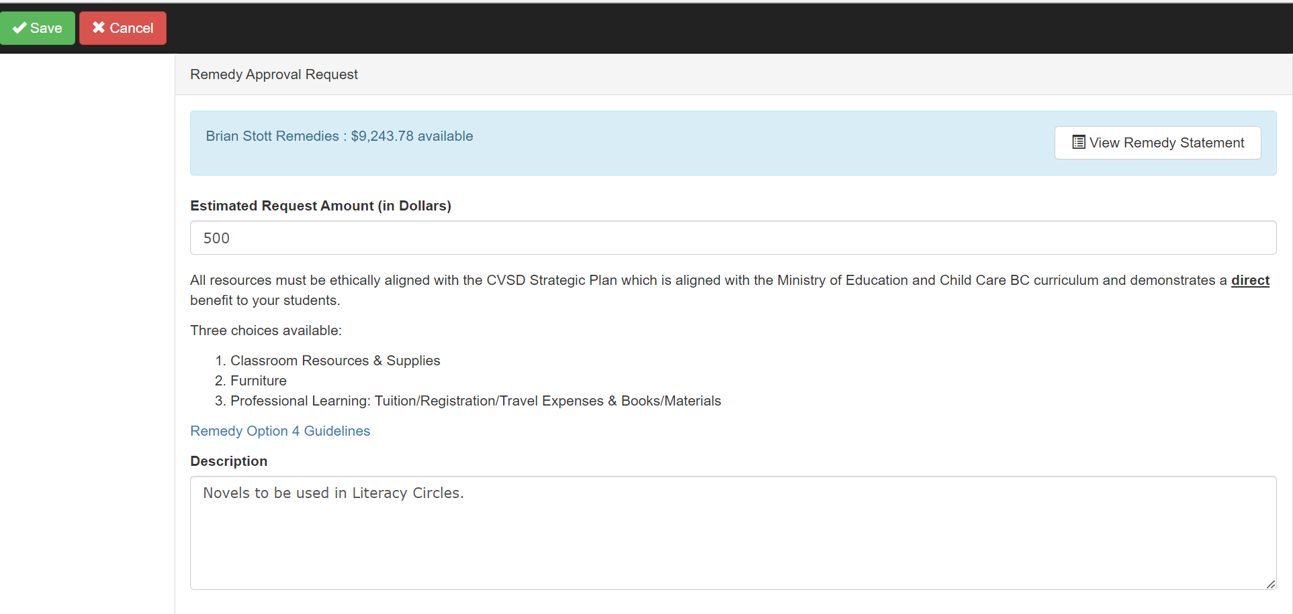

Select SAVE (top left corner)
Once saved, you will need to confirm the use of your request is 100% for teaching purposes. Please select “OK”.

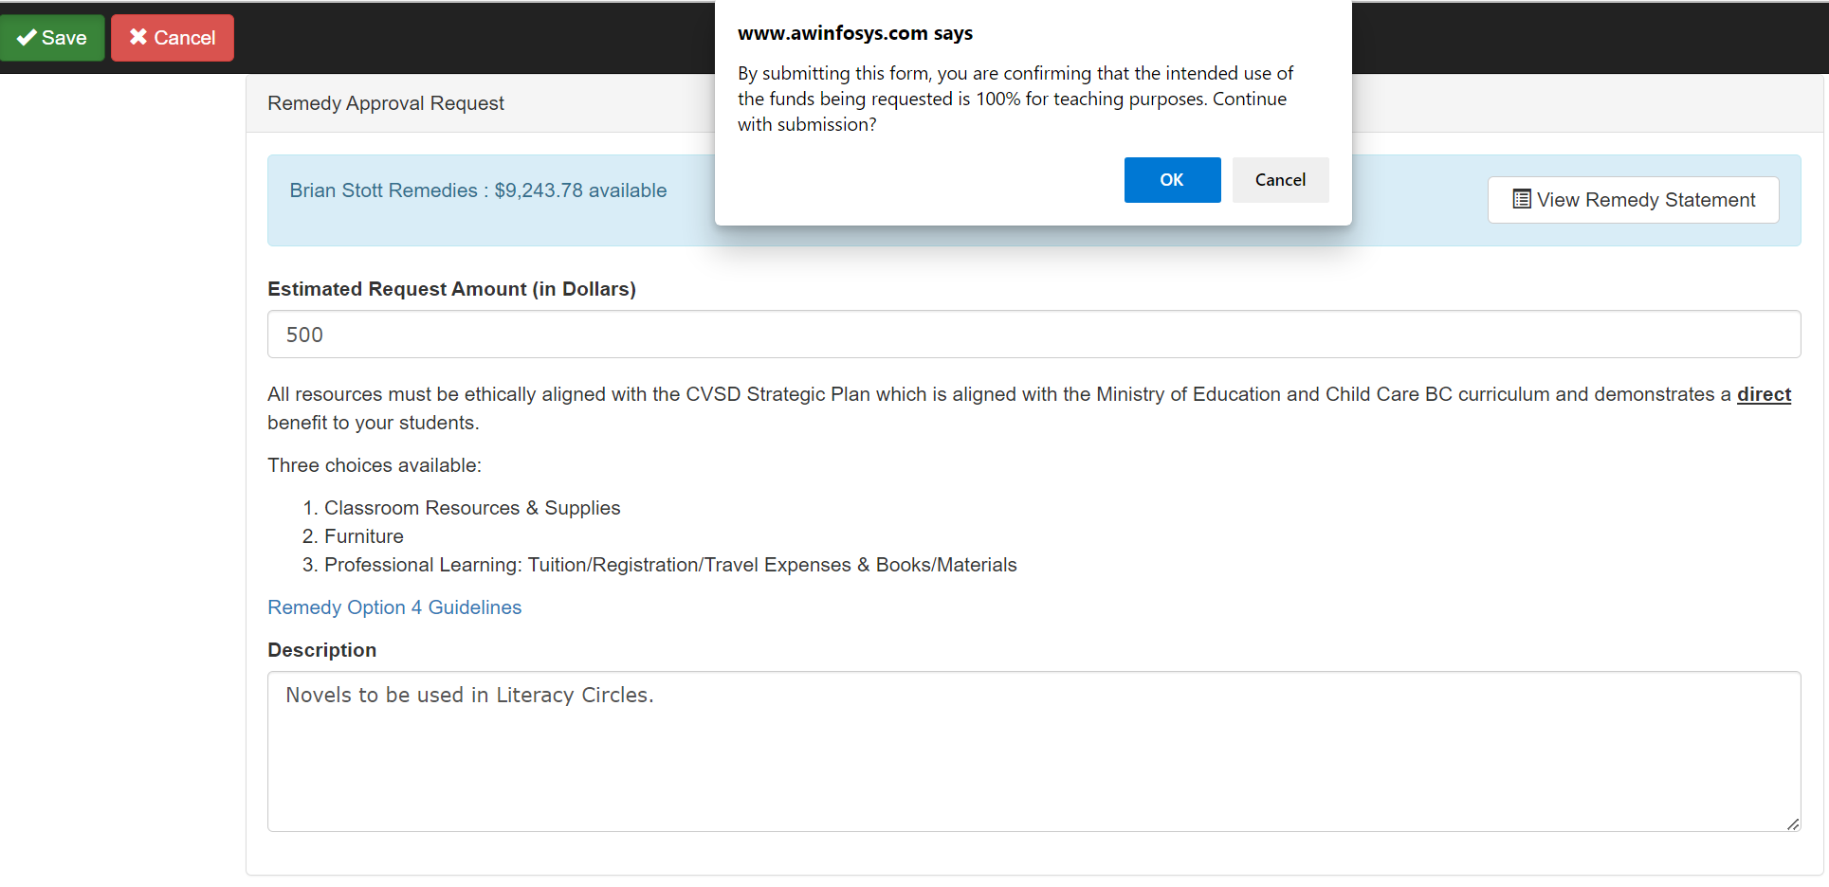

Once submitted, your request will appear as “In Review” until approved.
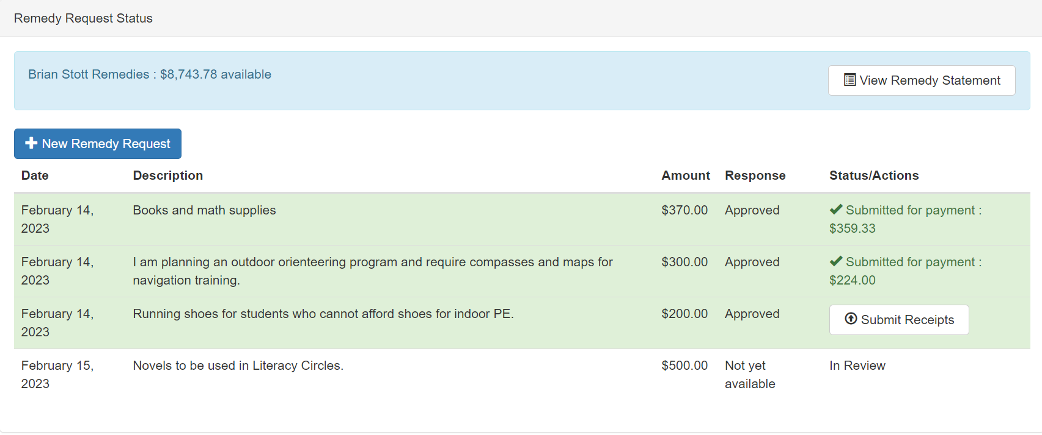
You will receive a notification once your request has been reviewed. Your request will either be Approved, Denied, or more information may be required. The “Response” column will indicate once your request has been approved. An email will also be sent to your school district email account.

Once your request has been approved and you have made your purchases, you will need to submit your receipts for reimbursement. Select the “Submit Receipts” button.
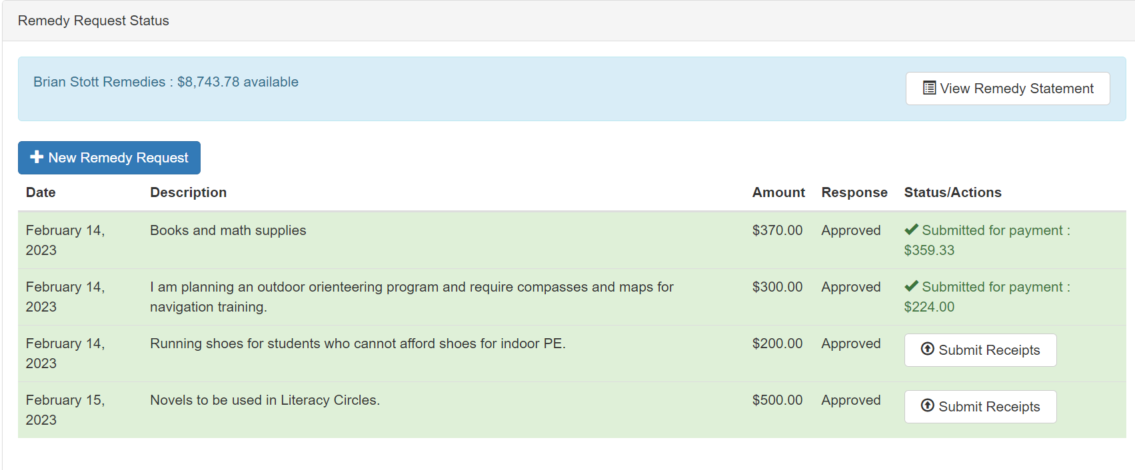

Enter your receipts. Separate your book and non-book values (this is for GST rebate purposes). Enter your taxes and ensure the auto-fill receipt total field matches your receipt.
Enter all receipts that relate to that specific remedy request. You can not exceed the value of the remedy request.

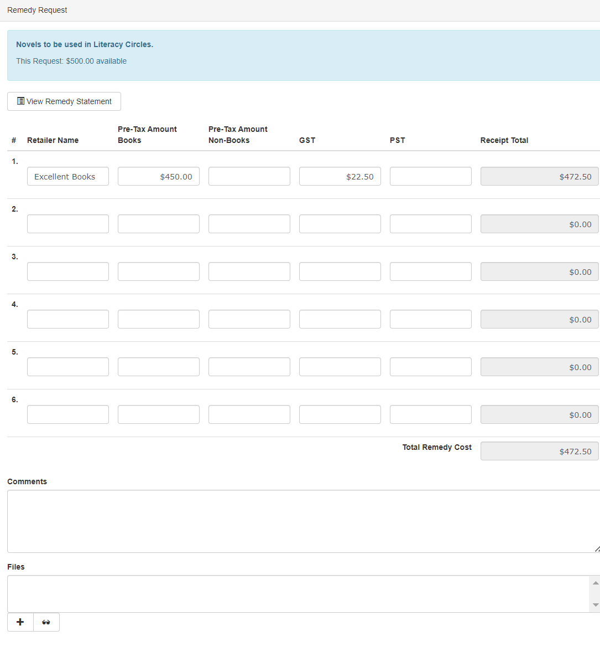
A copy of the receipt must be attached. Click the “+” under Files.

Give a description for your receipt and attach your file. Receipts must be in PDF or JPEG format. Select Save.

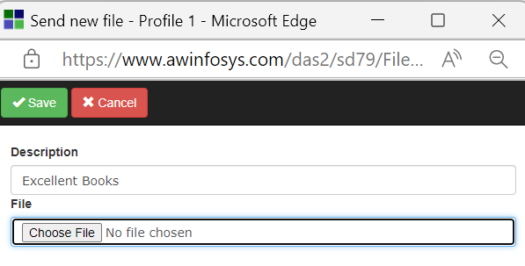

Once you have successfully uploaded your receipt(s) and saved, the following message will appear.
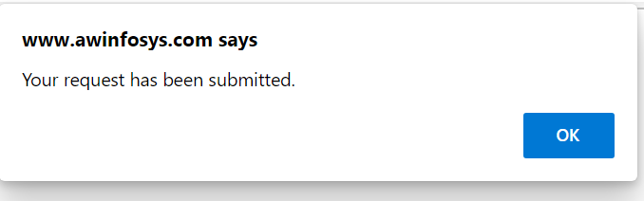

You will receive reimbursement for your submission within 3 weeks. This is processed through the Accounting Department and will be direct deposited to your bank account on file.
Once reimbursement has been made by Accounting, the transaction will be posted to your remedy statement.
