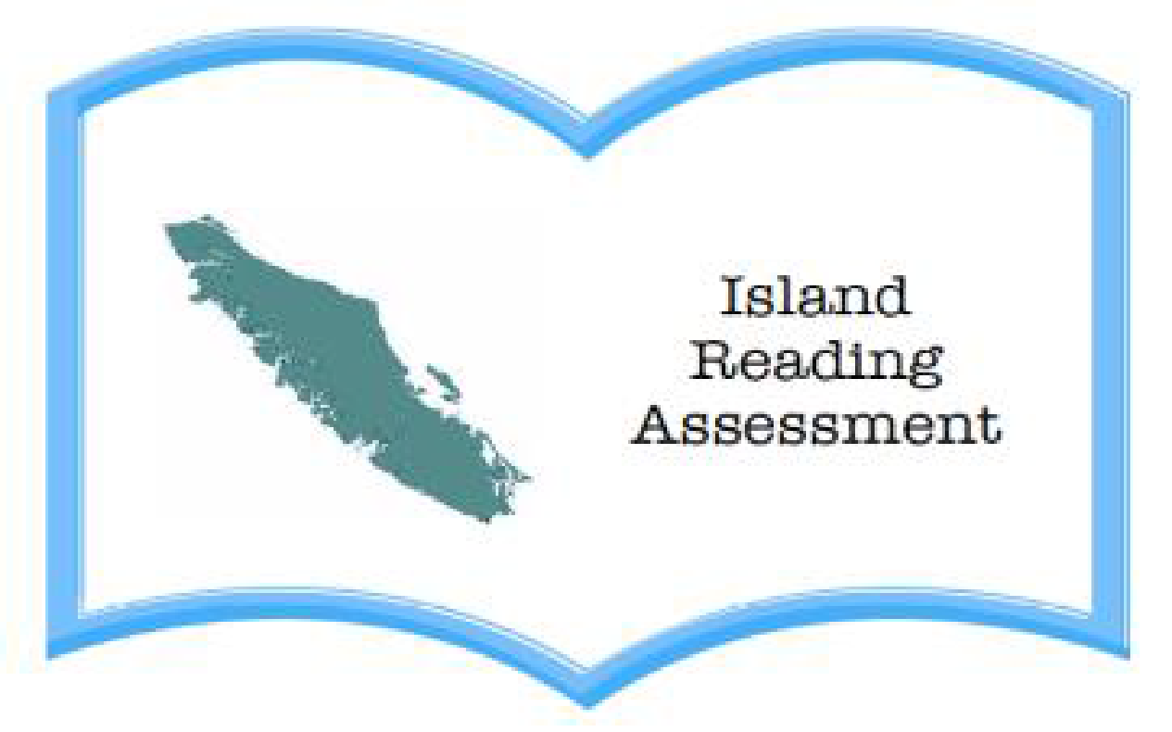

Name: ________________

Date: ________________

1. Find a way to show that you know what this text is about (you can make a web, a chart, or drawings with labels). Represent the topic and main ideas.

2. How does what you just read remind you of something you already know?

This reminds me of ____________________________________________________________
____________________________________________________________________________________________________________________________________________________________________________________

3. What else do you wonder about this topic or article?

I wonder ____________________________________________________________________________________________________________________________________________________________________________________

I think that
________________________________________________________________________________________________________________________

4. Write new or interesting words that you discover.
________________________________________________________________________________________________________________________

5. In what way has your thinking changed after reading this text?

I have learned ________________________________________________
_________________________________________________________________________________________________________________________________________________________________________________________________________

