Year-End District Evidence/Data Collection Procedures

Teacher Procedures

- On a web browser navigate to https://www.awinfosys.com/das2/sd79/ Login with your UserID and Password. If you do not have login information, contact Tech Services at techservices@sd79.bc.ca or call 250-748-0321 ext 217

- Once logged in you will see a screen similar to the following:

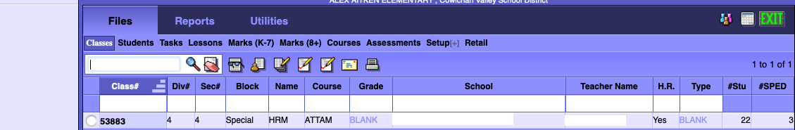

- Click on the Assessments Link under the Files tab to show a list of all assessments from which to select.

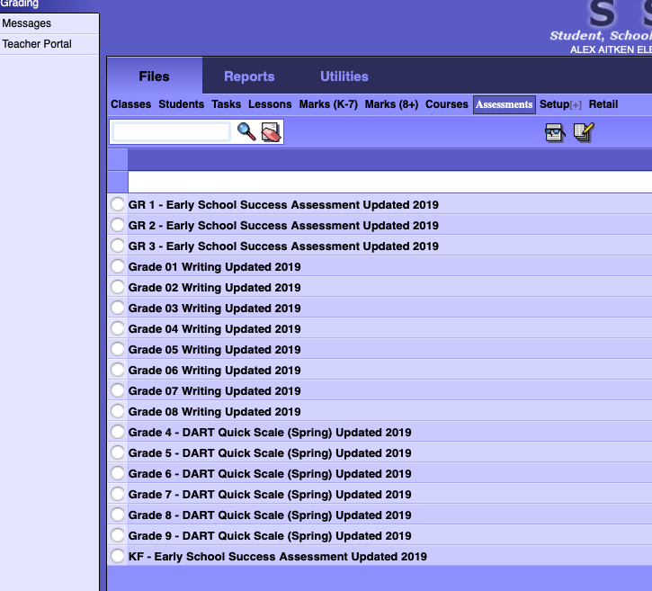

- Place a dot beside the assessment you wish to complete and click on the 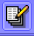 icon to open your class list.

- Enter a number from 1-4 in the field beside each student. One represents Emerging and four Extending on the Proficiency Scale. Click on the column heading to show the Proficiency Scale.
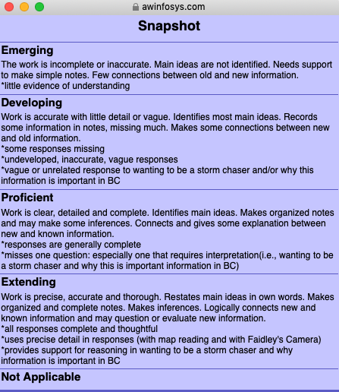
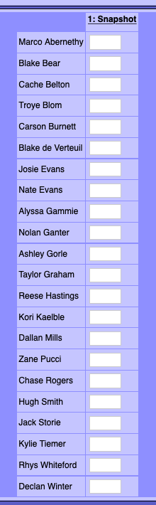

- IMPORTANT – Click the green check at the top left of the screen to save your entries or the red circle to cancel 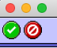 before leaving the window.

